County/District Unit Name: _______________________________

Team Members: _____________________ /_____________________
Time Start: ____________ Time End: ____________
----------------------------------------------------------------------------------------------- FCS Judging – SENSORY
-----------------------------------------------------------------------------------------------
Write the name of the odor next to each jar number below. The word bank offers a list of possible choices. Not all choices will be used. 20 minutes is the time allowed for completion.

100 _______________________
Odor Choices:

Almond Extract
Baking Spice
Bay Leaves
Butter Flavoring
Chili Powder
Cinnamon Powder
Cocoa Powder
Curry Powder
Garlic Powder
Nutmeg
Onion Powder
Parsley
Pepper
Taco Seasoning
Vanilla Extract

111 _______________________
122 _______________________
133 _______________________
144 _______________________
155 _______________________
166 _______________________
177 _______________________
188 _______________________
199 _______________________
200 _______________________
211 _______________________

K-State Research and Extension is an equal opportunity provider and employer

Sensory Rubric:

Item # | 3 Points | 2 Points | 1 Point | 0 Points
 | Correct odor label selected, label is spelled correctly, label is used only once | Correct odor label selected, label spelled incorrectly, label used more than once | Label spelled incorrectly or label used more than once | Incorrect label listed or item left blank
100
111
122
133
144
155
166
177
188
199
200
211
TOTAL:

- Each response is worth 3 points.
- Name and unit is worth 1 point.
- Completion within time limit is worth 3 points.
- Total value of Sensory is 40 points.

County/District Unit Name: ___FCS Update February 2017 Key__

Team Members: _____________________ /_____________________
Time Start: ____________ Time End: ____________
----------------------------------------------------------------------------------------------- FCS Judging – SENSORY
-----------------------------------------------------------------------------------------------
Write the name of the odor next to each jar number below. The word bank offers a list of possible choices. Not all choices will be used. 20 minutes is the time allowed for completion.

100 ____Taco Seasoning______
Odor Choices:

Almond Extract
Baking Spice
Bay Leaves
Butter Flavoring
Chili Powder
Cinnamon Powder
Cocoa Powder
Curry Powder
Garlic Powder
Nutmeg
Onion Powder
Parsley
Pepper
Taco Seasoning
Vanilla Extract

111 ____Cocoa Powder_______
122 ____Curry Powder________
133 ____Nutmeg_____________
144 ____Bay Leaves__________
155 ____Almond Extract_______
166 ____Pepper_____________
177 ____Parsley_____________
188 ____Garlic Powder________
199 ____Vanilla Extract________
200 ____Cinnamon Powder_____
211 ____Onion Powder________

K-State Research and Extension is an equal opportunity provider and employer

Creating Your Own Sensory Experience:

Thank you for your interest in offering a Sensory Experience for your local youth! Here are some helpful hints to help you create your own Sensory Experience.
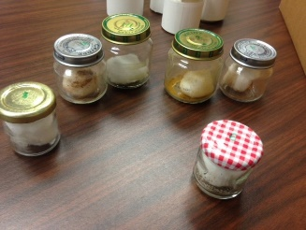
- Locate some small jars or small containers with removable lids. Note: I used baby food jars, but other small similar sized containers will work too.

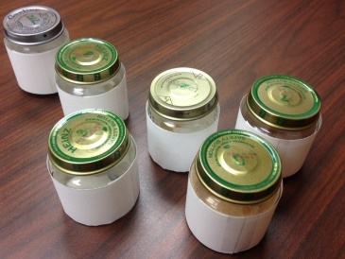
- Select a spice/seasoning to place inside each jar. Note: I selected a variety of seasonings/spices. I also added a cotton ball to each jar. The cotton ball can help control moisture and keep the powder in the jar.

- Wrap each jar/container with a piece of paper to encourage participants to utilize their sense of smell to identify the odor.

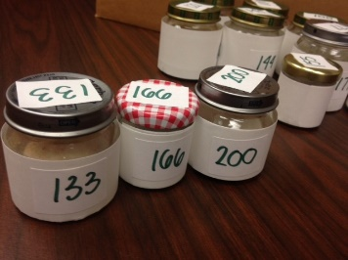
- Label each jar with a unique number. Be sure to place a label on the lid and on the side of each jar.

- Create response sheet similar to this file.

- Create an answer key for scoring purposes.

- Print rubric copies to use for scoring participant responses.

- Provide a timing device for youth to use when participating in the activity. Kitchen timers work great, or a timer can be set on a phone.

- Score and return response sheet to participants.

