2015 and 2016 Kansas 4-H Horticulture Judging
Written Exam Information
The study material for the years 2015 and 2016 is taken from The Kansas Garden Guide, publication S-51 (Rev.) March 2010. This publication is available for purchase at local Extension offices or can be downloaded The Kansas Garden Guide.

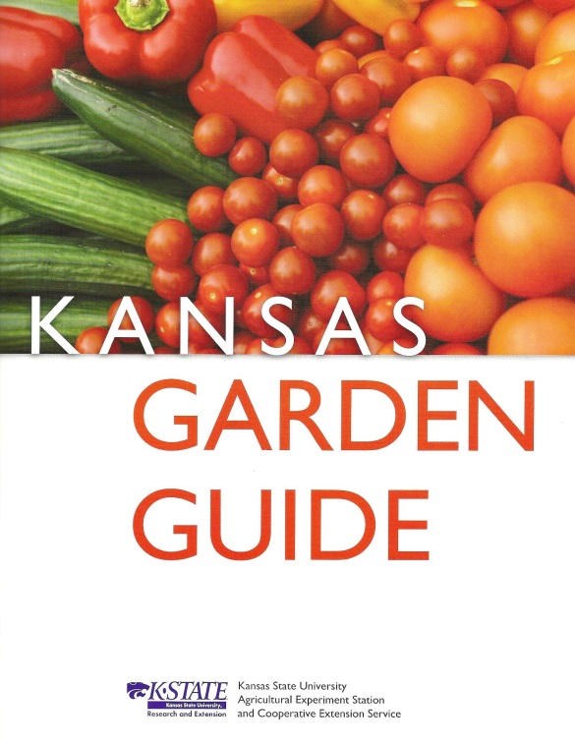 | The written exam selections include  pp. 5-23  - Introduction  - Planning a Garden  - Composting  - Soil Improvement  - Seeding and Planting  pp. 71-74  - Herbs

****BE SURE YOU USE THE 2010 VERSION OF THE KANSAS GARDEN GUIDE (PICTURED ABOVE) ****

