2017 and 2018 Kansas 4-H Horticulture Judging
Written Exam Information
The study material for the years 2017 and 2018 is taken from The Kansas Garden Guide, publication S-51 (Rev.) March 2010. This publication is available for purchase at local Extension offices or can be downloaded The Kansas Garden Guide.

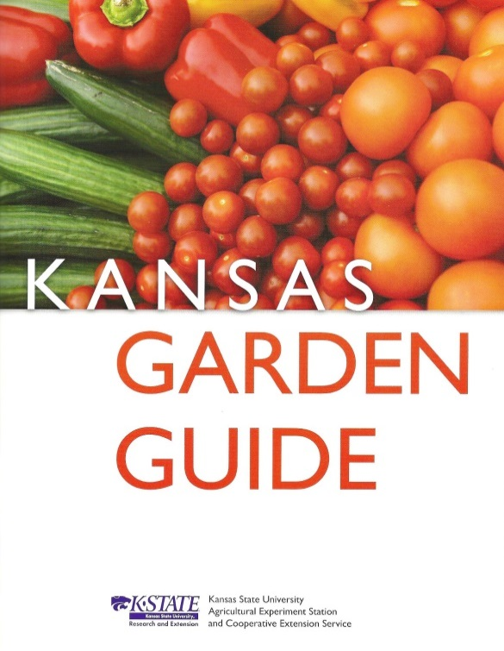 | The written exam selections include  pp. 25-29  - Watering the Garden  pp. 51-70  - Vegetable Crops

****BE SURE YOU USE THE 2010 VERSION OF THE KANSAS GARDEN GUIDE (PICTURED ABOVE) ****

