CLOVER COUNTY FAIR

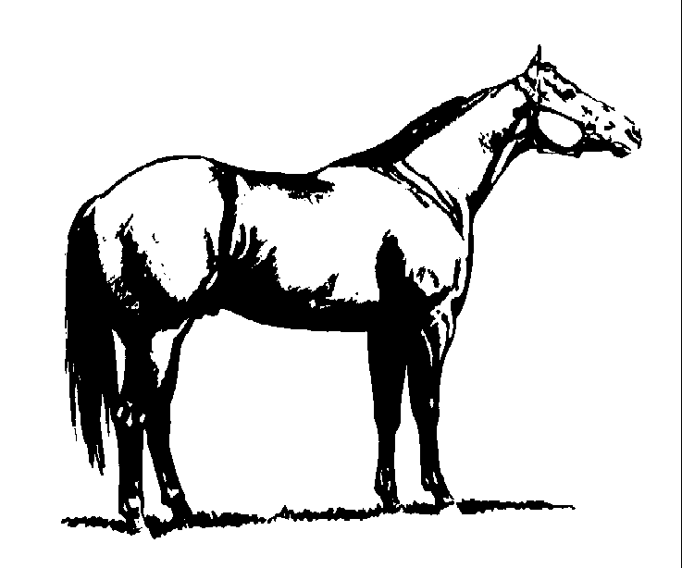

4-H MEMBER:___________________________

NAME OF ANIMAL:_______________________

BREED:________________________________

SEX:_____________ AGE:________________