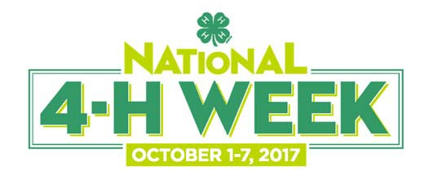
For Immediate Release

[Insert name of County/District] Youth to Celebrate National 4-H Week October 1-7

City, State (Month, Day, Year) — For the 75th consecutive year, millions of youth, parents, volunteers and alumni across the country will be celebrating National 4-H Week during the first full week of October. [Name of county/district] 4-H will leverage National 4-H Week this year by showcasing the incredible experiences that 4-H offers young people, and will highlight the remarkable 4-H youth in our community who work each day to make a positive impact on those around them.

[Insert a paragraph detailing how your program will be celebrating 4-H Week here]

“[Place quote from a local 4-H staff member about the value of the 4-H experience and how the youth have contributed to the community],” said [Individual's name and title]. "[Highlight a specific project and the effect it will have on the community]."

[Insert a paragraph highlighting the most popular and/or the newest 4-H programs offered in your county/district.]

4-H alumni around the country are always the first to acknowledge the significant positive impact 4-H had on them as young people; the opportunities and experiences that 4-H provides youth empowers them to become true leaders. In fact, research has shown that young people in 4-H are almost four times as likely to contribute to their communities, and are twice as likely to engage in Science, Technology, Engineering and Math (STEM) programs in their free time.

In [name of county/district], more than [number] 4-H youth and [number] volunteers from the community are involved in 4-H.

One of the most anticipated events of National 4-H Week every year is 48 Hours of 4-H, which gets hundreds of young people across Kansas taking part in youth-led community service projects. On October 7 and 8, 4-H Clubs will be out in full force, giving their time and talents in an effort to give back to their communities. Service projects range from cleaning parks to painting facilities, to visiting nursing homes and organizing food drives. To learn more about 48 Hours of 4-H, visit http://www.kansas4-h.org/events-activities/conferences-events/48-hours-of-4-h/index.html

About Kansas 4-H:
Kansas 4-H empowers young people with the skills to lead for a lifetime. K-State Research and Extension 4-H Youth Development programs reach over 77,000 Kansas youth across all 105 counties. Youth collaborate with caring adult mentors to lead hands-on projects in areas like science, health, agriculture and citizenship. Mentors provide a positive environment where youth learn by doing. To join a 4-H club, become a 4-H volunteer or for more information, visit www.Kansas4-H.org or find us on Facebook at www.facebook.com/Kansas4H .

###

Contact:
[insert name], [insert title]
[insert telephone number], [insert E-mail address] #

