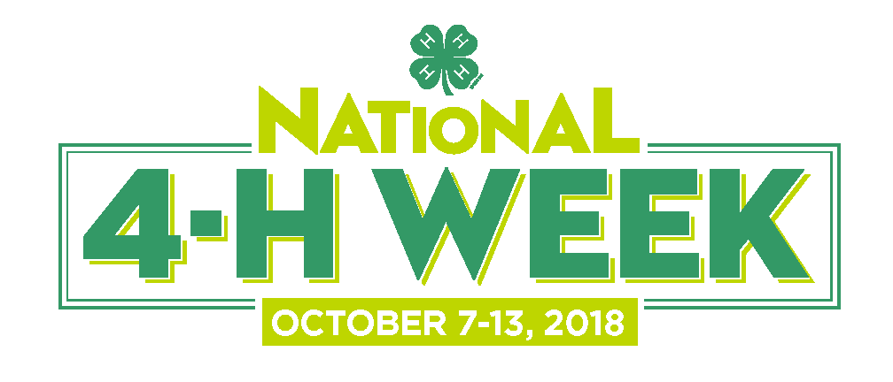

For Immediate Release

[Insert name of county] Youth to Celebrate
National 4-H Week October 7-13

City, State (Month, Day, Year) — For the 76th consecutive year, millions of youth, parents, volunteers and alumni across the country will celebrate National 4-H Week from October 7-13. This year's theme, Inspire Kids to Do, is a campaign that will give kids more opportunities to do, empowering them with the skills they need to succeed in life and career.

Throughout National 4-H Week, [Name of county] 4-H will showcase the many ways 4-H inspires kids to do through hands-on learning experiences as well as highlight the remarkable 4-H youth in our community who work each day to make a positive impact on those around them.
4-H was founded on the belief that when kids are empowered to pursue their passions and chart their own course, their unique skills grow and take shape, helping them to become true leaders in their lives, careers and communities.
[Insert a paragraph detailing how your local program will be celebrating 4-H Week here]

“[Place quote from a local 4-H volunteer about the value of the 4-H experience and how the youth have contributed to the community],” said [Individual's name and title]. "[Highlight a specific project and the effect it will have on the community]."

[Insert a paragraph highlighting the most popular and/or the most innovative 4-H programs offered in your county.]

4-H alumni around the country are always the first to acknowledge the significant positive impact that 4-H had on them as young people. In fact, research has shown that young people in 4-H are nearly four times as likely to contribute to their communities and are twice as likely to engage in Science, Technology, Engineering and Math (STEM) programs during after school time.

In [name of county], more than [number] 4-H youth and [number] volunteers from the community are involved in 4--H.

To learn more about joining 4-H or becoming a Kansas 4-H volunteer, please visit www.Kansas4-H.org or follow us on Facebook and Twitter.
###

Contact: [insert name], [insert title]
[insert telephone number], [insert E-mail address]

