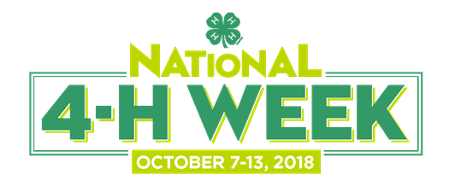

National 4-H Week Proclamation Template
WHEREAS, 4-H is America’s largest youth development organization, supporting nearly six million youth across the country; and
WHEREAS, 4-H has helped [number] youth in [county/district/state] to become confident, independent, resilient and compassionate leaders; and
WHEREAS, 4-H is delivered by Cooperative Extension – a community of more than 100 public universities across the nation that provides experiences where young people learn-by-doing through hands-on projects in the important areas of health, science, agriculture and civic engagement; and
WHEREAS, National 4-H Week showcases the incredible ways that 4-H inspires kids to do and highlights the remarkable 4-H youth in [county/district/state] who work each day to make a positive impact on those around them; and
WHEREAS, 4-H’s network of nearly 500,000 volunteers and 3,500 professionals provides caring and supportive mentoring to all 4-H’ers, helping them to grow into true leaders, entrepreneurs and visionaries;
NOW, THEREFORE, I, [name, title], do hereby proclaim October 7-13, 2018 as NATIONAL 4-H WEEK throughout [city/county/state] and encourage all of our citizens to recognize 4-H for the significant impact they have made and continue to make by empowering youth with the skills they need to lead for a lifetime.

___________________________________________________________________________
^{4-H Youth Representative} ^{Date}

___________________________________________________________________________
Signature of Authorizing Official ^{Date}

