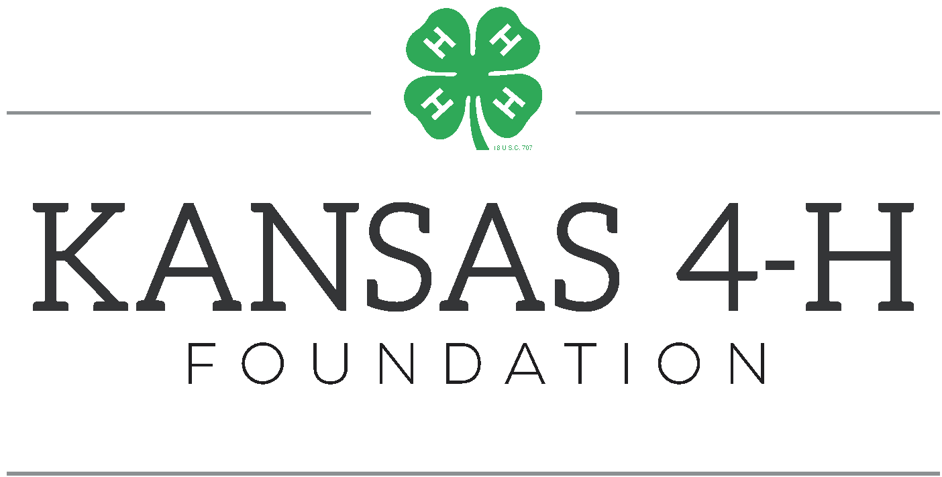

April XX, 2021
FOR IMMEDIATE RELEASE

Contact: Insert contact name
Phone: Insert phone number
Email: Insert email
XXXXXXXX 4-H CLUB VOTES TO ENDORSE THE COURSE

CITY, Kan. April XX, 2021— The XXXXXXXX 4-H Club voted to Endorse The Course at Rock Springs Ranch during their April meeting. All Kansas 4-H Clubs were challenged by the Kansas 4-H Youth Leadership Council to make a gift for the construction of a new Leadership Adventure Course for Rock Springs Ranch, the State 4-H Center located south of Junction City, Kan. The Leadership Adventure Course is a team-obstacle course with high ropes, low elements and a dueling zip line to use as leadership development tools.
“The XXXXXX 4-H Club voted to Endorse The Course because ____________________.,” First Name Last Name, club role, said. “I am excited about this new activity at Rock Springs Ranch _____________________.”
Together, Kansas 4-H Club’s have a goal to raise $25,000 for the Leadership Adventure Course by May 1. For every $5,000 clubs raise, generous donors who believe in the resilience of Kansas 4-H members will match every gift dollar for dollar, up to $25,000.

Kansas 4-H youth will get to enjoy the new Leadership Adventure this summer, 75 years after Rock Springs Ranch was founded. In 1945, Kansas 4-H Clubs purchased the land that is now Rock Springs Ranch to be the state 4-H center for Kansas youth. Kansas 4-H Clubs participating in the Endorse The Course challenge are continuing the tradition of youth philanthropy. XXXXXXXX 4-H club invites others to join them and Endorse the Course by making a gift at kansas4hfoundation.org/ETC.

“It is so cool that we get to be a part of the tradition for Kansas 4-H Clubs to come together,” Korben Clawson, Kansas 4-H Youth Leadership Council Member, said. “Kansas 4-H Clubs around the state are pledging their hands to larger service and contributing to the next 75 years of Rock Springs Ranch. This is our legacy for the next generation of Kansas 4-H members.”

4-H is the state’s largest positive youth development program with over a century of presence in Kansas. Kansas 4-H shapes youth to be dynamic leaders and community members through experiential learning opportunities. These opportunities range from project participation to leadership training to 4-H camp at Rock Springs Ranch. At capstone 4-H experiences such as the county fair and 4-H camp, youth engage in research-based, rich learning opportunities where they learn mastery, independence, belonging and generosity.
XXX INSERT WORD COUNT OF ARTICLE

