Meeting the Needs of Youth Worksheet

The Need to Belong The Need to Be Generous
List ways 4-H clubs help: List ways 4-H clubs help:

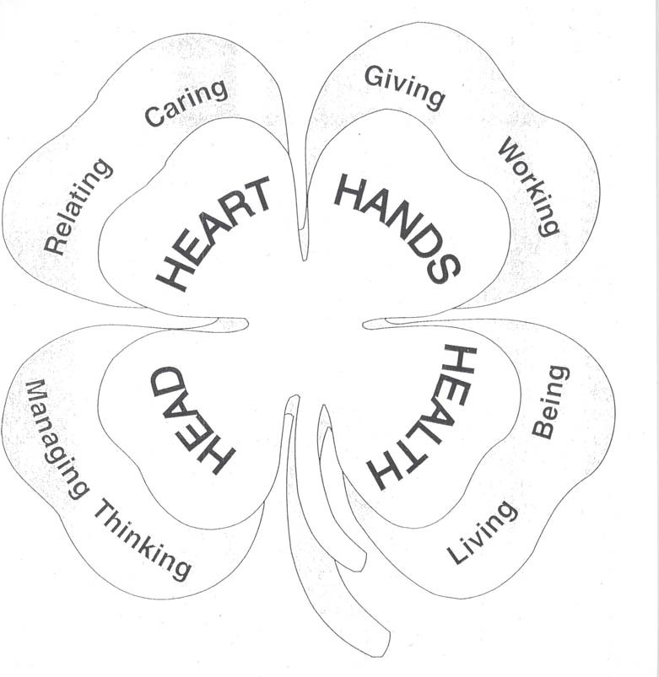

The Need to Be Independent The Need to Master
List ways 4-H clubs help: List ways 4-H clubs help:

