Types of Group Environment

Physical Environment - the space in which the group organizes, conducts business, or networks.

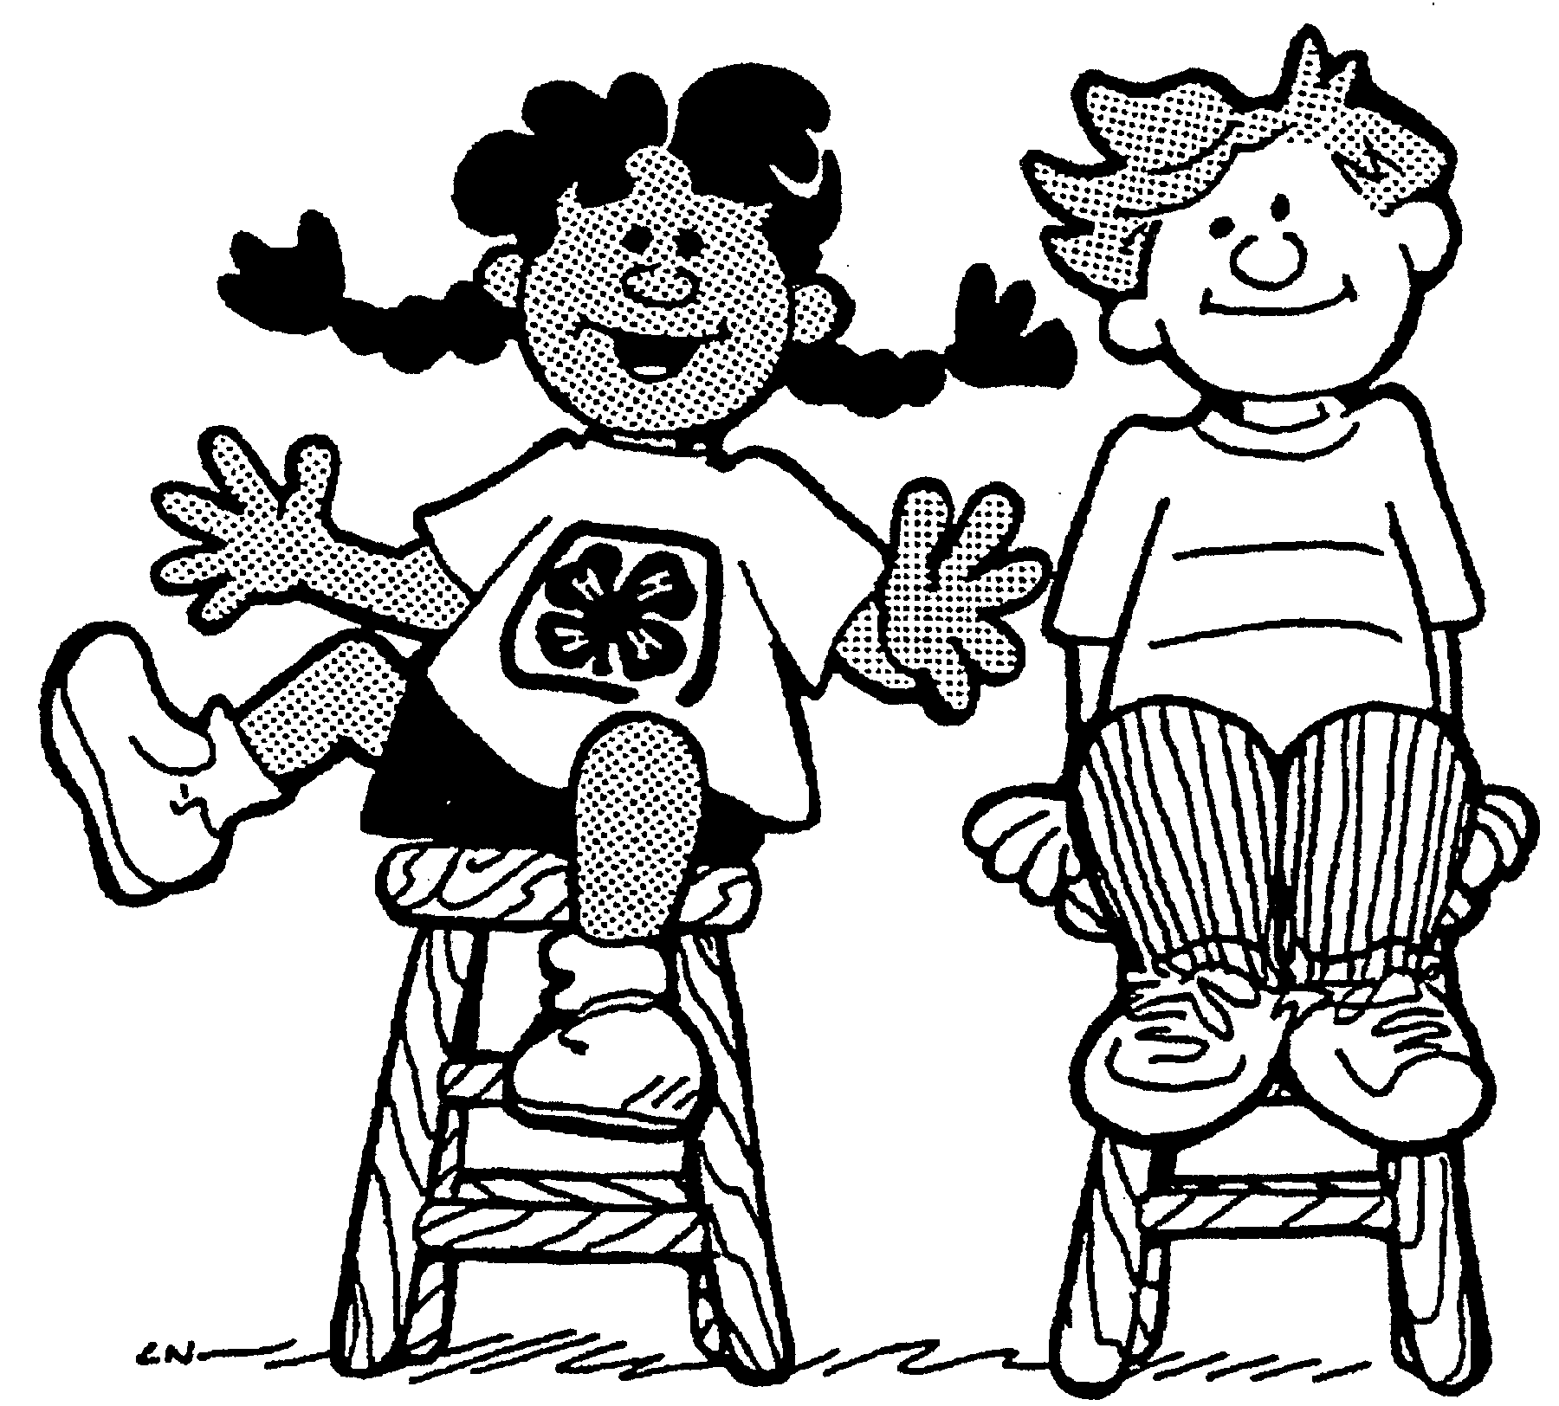

Social Environment - how group members relate and interact with one another.
Maintaining the emotional state of the members healthy so they can work together, effectively. Trust is an important element.

Personal Environment - how the member feels within the group. Their comfort level.

