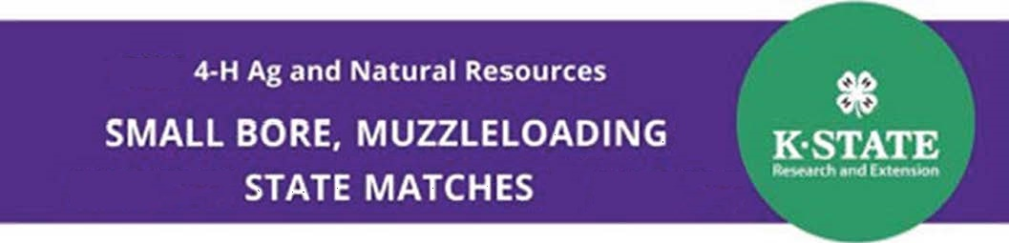
Smallbore Rifle, Smallbore Pistol, Muzzleloading State Matches will be held on October 1st, 2022 at the Capital City Gun Club, 12200 NW 4th St, Topeka, KS 66615.
Day Check-In & Equipment Check
- Participants must check in on time.
- Coaches will confirm teams at Check-In.
- Youth will confirm relay.
- Check-In will begin at 8:00 AM & 12:30 PM
- First relays begin shooting at 9:00 AM.
- Afternoon relays begin at 1:00 PM
- Concessions will be available this year.
- An awards ceremony will be held in the afternoon at the conclusion of the match after final scores are tabulated.
- The deadline for submitting applications for Archery, Muzzleloading, Shotgun, Small-Bore Pistol, and Small-Bore Rifle disciplines is October 14, 2022. The link for additional information is: https://www.kansas4-h.org/events-activities/conferences-events/shooting-sports/national-invitational/index.html
- We plan to have the National Tom Davison Sweepstake Trophy at the match for viewing and photo opportunities.

