CLOVER COUNTY FAIR
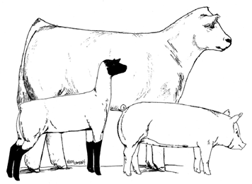
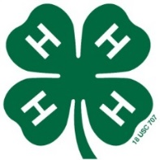
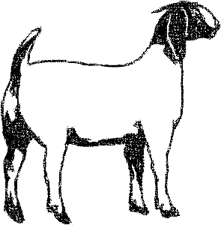

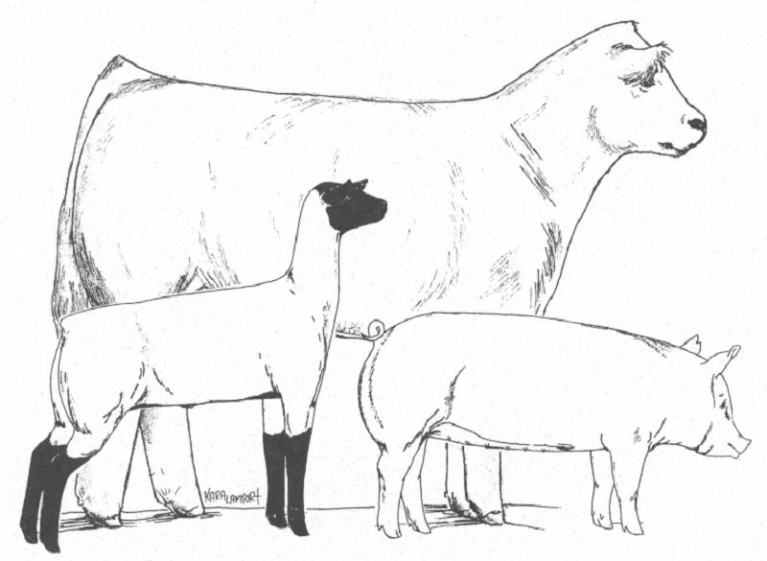
4-H MEMBER: ___________________________
NAME OF ANIMAL: _______________________
BREED: ________________________________
START WEIGHT: END WEIGHT: RATE OF GAIN:
_________ _________ _________

