4-H MEMBER:___________________________________

NAME OF ANIMAL:_______________________________

BREED:________________________________________

SEX:____________ AGE:_______________

CLOVER COUNTY FAIR

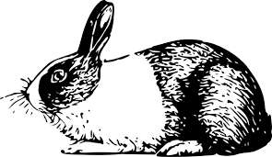

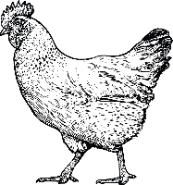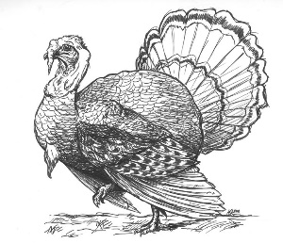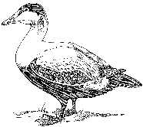

4-H MEMBER:___________________________________

NAME OF ANIMAL:_______________________________

BREED:________________________________________

SEX:____________ AGE:_______________

CLOVER COUNTY FAIR