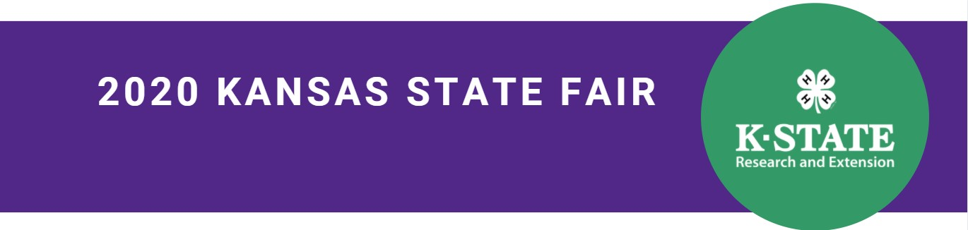

Dear 4-H Exhibitor:

Congratulations! Your 4-H exhibit has been selected to represent your county/unit for the Kansas State Fair 4-H virtual exhibition. We know this will be different from having an in-person exhibit at the Kansas State Fair. However, Kansas 4-H values the opportunity to provide feedback for its member’s project work and wants to showcase the amazing accomplishment and learning your exhibit represents.

You will find requirements for your exhibit’s project area under 2020 4-H Kansas State Fair Upload Organization on the 2020 Virtual Exhibition Information webpage. It is your responsibility to decide how to best showcase your exhibit in picture form which you will submit to the Extension Office. We worked with superintendents and judges establish what they needed to evaluate and provide feedback for each project area. Please only submit the files requested for your exhibit.

By providing the information requested, your family agrees that the information and image(s) of the exhibit will be made available to the public as part of the exhibit showcase.

Prepare your exhibit photos carefully. Members are asked to present their exhibit(s) in the best way possible with accuracy and honesty.
Tips to consider as you prepare your photos:
- Try to use natural lighting.
- Avoid direct sunlight.
- Avoid cluttered backgrounds.
- Do not crop or resize images.
- Do not digitally alter images.
- Take photos from various angles if not specified for the exhibit (front, back, top, bottom, side, far away, close up, etc.).
- Include close-up shots to show-off details but avoid using the zoom on the camera - get physically closer instead.
- If relevant, include a ruler in one photo to provide scale reference.

Exhibit Submission
All exhibits must be submitted to your county Extension Office by (fill in the date). This will allow staff the time they need to upload all needed information into the FairEntry system.

The intent is to have all exhibits evaluated by September 9th and results shared out by September 12th. These dates are tentative. We hope there are minimal challenges with the virtual showcase. Please do be patient as we all work through new processes. As staff, we are learning as much as our 4-H members.

All information about the public showcase of exhibits and exhibit results will be posted to the 2020 Virtual Exhibition Information page.

We look forward to the day we can all be back together in person. Until then, we are committed to supporting learning, evaluating, and showcasing the achievements of Kansas 4-H members.

Our methods are changing, but our 4-H mission remains the same.

Sincerely,

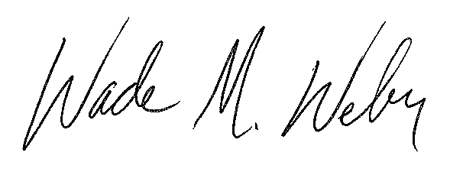

Wade M. Weber
Kansas 4-H Program Leader

