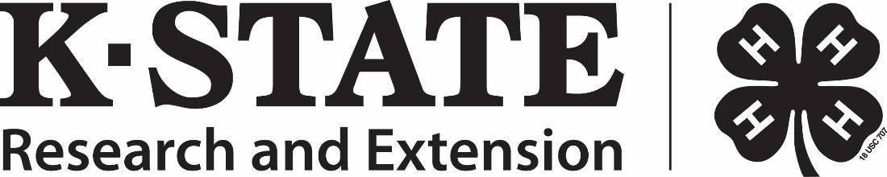
Below are resources that would be helpful for youth to review prior to the September 18, 2021 Family and Consumer Sciences Judging Contest:
Reading the New Food Labels
https://hgic.clemson.edu/factsheet/reading-the-new-food-labels/

Healthy Living / Dietary Guidelines for Americans 2020-2025
https://extension.sdstate.edu/dietary-guidelines-americans-2020-2025
https://www.aging.k-state.edu/programs/embracing-aging/docs/kea2eatingsmartmf3257.pdf
https://www.aging.k-state.edu/programs/embracing-aging/docs/kea3physicalactivitymf3258.pdf

Essential Living Skills – Apparel Management
https://bookstore.ksre.ksu.edu/pubs/S134H.pdf
Review these topics:
- Wardrobe Action Plan, pages 14 – 33
- Wash Wonders, pages 47-69

Bonding Thru Board Games
https://bookstore.ksre.ksu.edu/pubs/MF3401.pdf

Alternative Proteins
https://bookstore.ksre.ksu.edu/pubs/MF3476.pdf

Outdoor Adventures
https://bookstore.ksre.ksu.edu/pubs/4H1148.pdf

The contest includes ranking classes (completed as individuals) and team activities including a puzzle activity and “group think,” an oral reasons and ranking activity. The group think activity is optional but required if teams want to be considered for overall placings.
View this video to get an example of Group Think: 4-H Consumer Decision Making Group Think Example
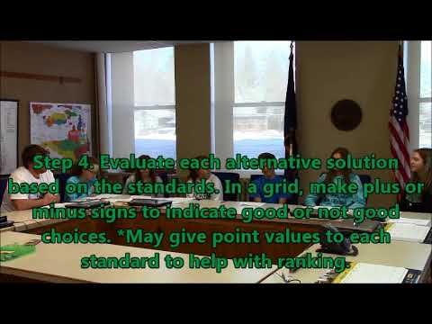
Step 1: State the problem or situation.
Step 2: List alternative solutions for the situation or problem.
Step 3: List the standards stated in the situation or problem. You may add additional standards even if they are not stated in the situation.
Step 4: Evaluate each alternative solution based on the standards. In a grid, make plus or minus signs to indicate good or not good choices.
Step 5. Select the best choice for the situation and explain your decision to the judge.
Teams will have __ minutes for this activity.
Teams will be provided with a printed copy of the situation (which will relate to one of the identified topics utilized in the contest), paper and markers.

